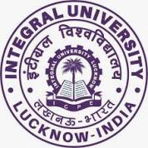

**Department of Biosciences**

**Integral University, Lucknow**

***DEPARTMENT OF BIOSCIENCES ORIENTATION PROGRAM 2022-23***

Integral University with the objective to welcoming new students to the university, has conducted the orientation program successfully for the session **2022-2023**. The program commenced with the centralized orientation program on **12th September 2022** at the **Convocation Main Lawn** from **4:00 PM** **onwards** in the presence of **Hon’ble Deputy Chief Minister Mr. Brijesh Pathak, Hon’ble Chancellor Prof. S.W Akhtar, Hon’ble Pro-chancellor Prof. Syed Nadeem Akhtar, Hon’ble Vice-Chancellor Prof. Javed Musarrat and other dignitaries**. They addressed the newly admitted students with their words of wisdom and welcomed all of them with great zeal and enthusiasm.

The next two days are dedicated to the departmental orientation program which was held in the departmental seminar hall, Academic Block B, Faculty of Science, Department of Biosciences on **13th September** and **14th September 2022,** respectively.

The **first day of the departmental orientation program**was held on **13th September** and started with the welcome address by **Dr. Amita Dubey,** she welcomed the Dean of Faculty of Science, **Prof. Abdul Rahman Khan**, Head  **Dr. Snober S. Mir**, faculty members, and students with their kind words followed by the introduction of the faculty members. The students were oriented about the requirements for UG/PG courses followed by a guest lecture by **Dr. Huma Mustafa, Joint Director (Biotechnology), CST UP, Lucknow** on “Career opportunities in Biosciences”**.** She apprised the students about various career opportunities in Modern biology and made them aware of different internships/fellowships available for research and development in Uttar Pradesh.

The program also witnessed a guest Lecture by **Dr. Vandita Srivastava, Independent Director on Board of Directors of QCS Herbals, Pune, Maharashtra.** She delivered a talk on “Entrepreneurial opportunities in Biological Sciences”**.** She talked about the role of students in industries focused on applications of medicinal plants and herbal drugs. The first edition of the quarterly newsletter (Issue I) **“BioScope”** was released by **Dr. Huma Mustafa,** the newsletter wasedited by the members of the Biosciences Students’ Council **Mr. Mohd Danish Khan (B.Sc Life Sciences)** and  **Ms. Affiya Azhar (B.Sc Biotechnology),** mentored by **Dr. Snober S Mir, Dr. Swati Sharma** and **Dr. Arshi Siddiqui.** The program concluded with a vote of thanks by **Dr. Jahanarah Khatoon.**

After the tea break students were oriented by representatives from various cells including, **Ms. Kashifa** from the departmentallibrary, **Dr. Sufia Rehman** from CCG&D center, **Dr. Iffat Zareen Ahmad** Chairperson from Women Grievance Cell **, Er. Poonam Sharma** from NSS**, Dr. Salman Khan** from the alumni cell, and **Ms. Sadiya Samreen,** Hostel Warden.The first day ended with a general vote of thanks for the whole departmental orientation by **Dr. Uzma Afaq**.

The **second day of the orientation** Program witnessed various knowledge-gaining activities organized by the department of biosciences on **14th September, 2022**. The second day of the program started with a welcome note by **Dr. Hayatul Islam** and a briefing about the day’s program. The day commenced with the campus visit and central library visit. The day started with a discussion about UG/PG ordinances, addressed by Chairperson DQAC and PG coordinator **Dr. Mohammad Salman Khan,** and UG coordinator, **Dr. Swati Sharma**. The program was continued with a TedEx video coordinated by **Dr. Swati Sharma,** andaddressed by **Dr. Arshi Siddiqui** coordinator, Departmental Website Committee (DWC) about the departmental website, Integral Learning Initiative (ILI), and student mobile applications for various academic purposes. The Departmental Placement coordinator **Dr. Irfan Ahmad Ansari** told them about placement and progression. The session continued with the final year UG/PG program student interactions which were coordinated by **Dr. Mohammad Ikram Ansari.**

The last day of the program marks up its end with the general vote of thanks for the whole departmental orientation by **Dr. Mohd Khubaib** by welcoming students with open hands and wishing them a new and happy academic journey.

The two days orientation program was well-organized by **Dr. Mohd. Ashfaque** and **Dr. Arshi Siddiqui** along with the faculty members and student representatives of the department.

**Glimpses of the event and minute-to-minute schedules.**

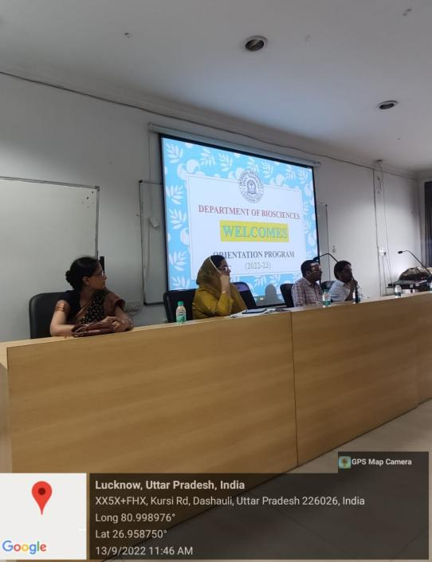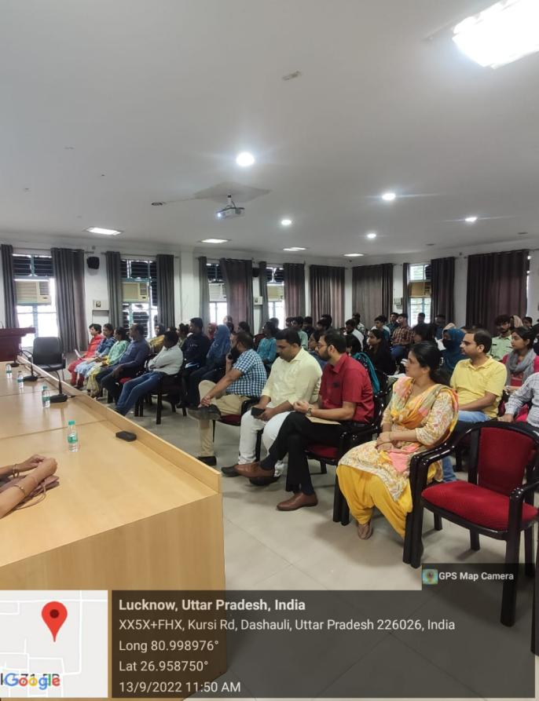

Glimpses of orientation program with faculty members and students

First day of the orientation program.

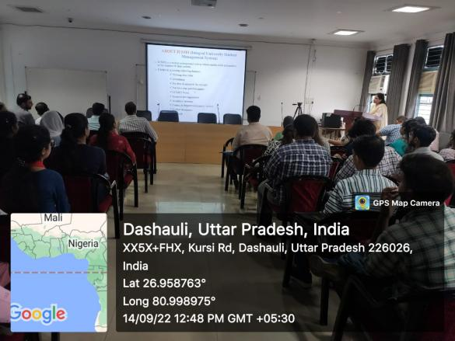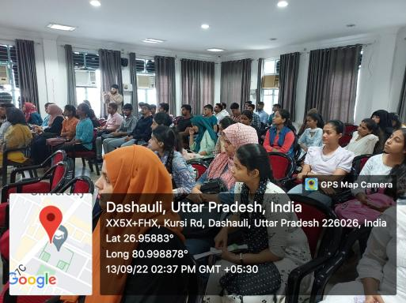

Students orientated during a guest lecture

Addressed by departmental website coordinator Dr. Arshi Siddiqui

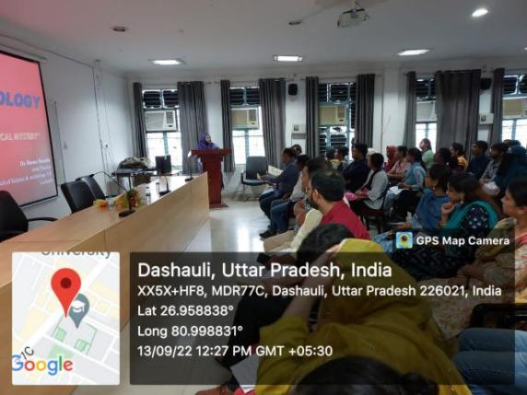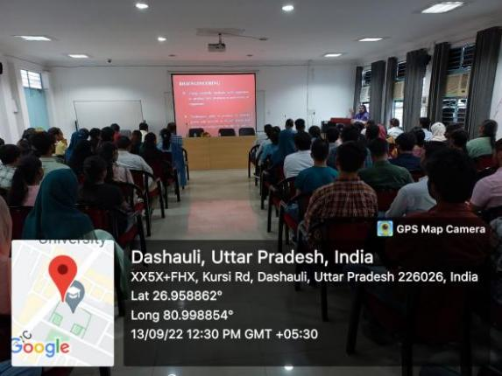

Glimpses of orientation program during a lecture session

Addressed by Dr. Huma Mustafa

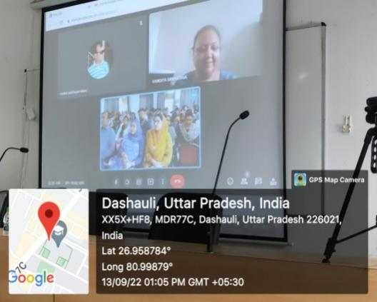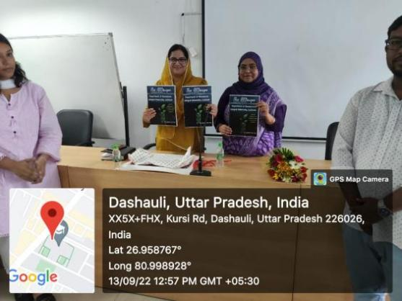

Inagural session of the BioScope newsletter

Addressed by Dr. Vandita Srivastava

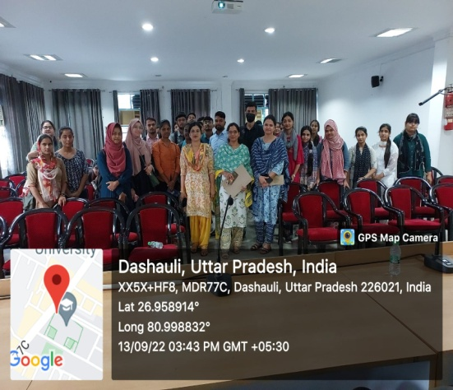

Last day of orientation program 2022-23

**HANDOUT**

**Schedule for Orientation Programme**

**Department of Biosciences**

**Venue: Departmental Auditorium**

**Day 1st (13 September, 2022)**

|  |  |
| --- | --- |
| 11:30 – 11:35 AM | Compering by **Dr. Amita Dubey** – Welcome |
| 11:35 – 11:50 AM | Address by HOD, Biosciences Dr. Snober S. Mir (History and Highlights of the Department, Progress, Achievements, etc.) |
| 11:50 – 12:20 PM | Self-introduction of faculty members and Staff (Profile should include name, academic background, expertise, achievements, subjects taught, R&D, research projects, publications/patents) |
| 12:20 – 12:50 PM | Expert Lecture by **Dr. Huma Mustafa, Joint Director (Biotechnology), CST UP, Lucknow** |
| 12:50 – 1:20 PM | **Expert Lecture by Dr. Vandita Srivastava, Independent Director on Board of Directors of QCS Herbals, Pune, Maharashtra** |
| 1:20 – 1:30 PM | Vote of Thanks by **Dr. Jahanarah Khatoon** |
| 1:30 – 2:00 PM | Lunch Break  **Refreshment Committee:** Mr. Mohammed Arif, Dr. Manzar Alam, Dr. Shahida Hamid, Ms. Smita Rai and Mr. Abdullah Hassan |
| **Common for Department of Biosciences and Bioengineering** | |
|  | Compering by **Dr. Sabihur Rahman** |
| 2:00 – 2:15 PM | Address by CCG&D representative |
| 2:15 – 2:20 PM | Address by **Ms. Kashifa** regarding Library rules |
| 2:20 – 2:40 PM | Address by CIED speaker from **Centre for Incubation & Entrepreneurship Development (CIED**) |
| 2:40 – 3:00 PM | Address by representative of Women Grievance Cell **Dr. Iffat Zarin Ahmad** |
| 3:00 – 3:15 PM | Address by NSS Representative **Er. Poonam Sharma** |
| 3:15 – 3:30 PM | Address by Alumni coordinated by **Dr. Salman Khan** |
| 3:30 – 3:40 PM | Address by Hostel Warden **Ms. Sadiya Samreen regarding rules and requlations** |
| 3:40 – 3:45 PM | Vote of thanks by **Dr. Uzma Afaq** and briefing about next day’s programme |

**Day 2nd (14 September, 2022)**

|  |  |
| --- | --- |
| 11:30 – 11:35 AM | Welcome by **Dr. Hayatul Islam** and briefing about the days programme |
| 11:35 – 11:45 AM | Address by Chairperson, DQAC **Dr. Mohammad Salman Khan** |
| 11:45 – 12:00 PM | Address by PG & UG coordinators (**Dr. Mohammad Salman Khan & Dr. Swati Sharma**) |
| 12:05 – 12:15 PM | TedEx Videos coordinated by **Dr. Swati Sharma** |
| 12:15 – 12:25 PM | Address by **Dr. Arshi Siddiqui** Coordinator, Departmental Website Committee (DWC) |
| 12:25 – 12:40 PM | Address by Departmental Placement coordinator **Dr. Irfan Ahmad Ansari** |
| 12:40 – 1:10 PM | Interaction with Students of final year of UG and PG Programs  Coordinated by **Dr. Mohammad Ikram Ansari** |
| 1:10 – 1:20 PM | Vote of Thanks by **Dr. Mohd Khubaib** |
| 1:20 – 2:00 PM | Lunch Break |
| 2:00 PM onwards | Visit of Campus/Department lab and classrooms/Central Library  **Dr. Farina Mujeeb, Dr. Sangeeta Singh, Dr. Mohsin Vahid Khan, Dr. Neha Mohd. Qasim** |